## ****OLED display module and HC05 or HC06 Bluetooth Module:****

If you have never used the [I2C supported Oled display module](https://www.electroniclinic.com/arduino-oled-i2c-display-128x64-with-examples-wiring-and-libraries-issues-solved/) and the [HC05 or HC06 Bluetooth module](https://www.electroniclinic.com/bluetooth-arduino-pin-code-and-name-changing-using-at-commands/) then I highly recommend reading my getting started tutorials, in which I have explained all the basics including technical specifications, Interfacing, and Arduino Programming.

## ****Soil NPK Sensor interfacing with Arduino, Circuit Diagram:****

[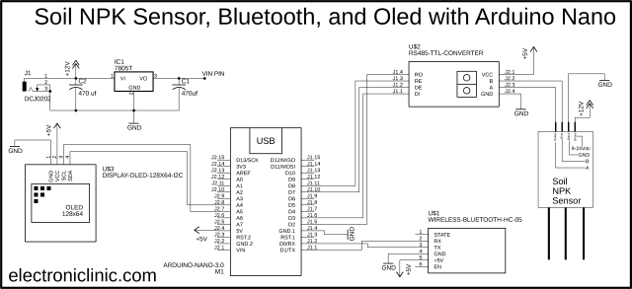](https://i1.wp.com/www.electroniclinic.com/wp-content/uploads/2021/03/Soil-NPK-Sensor-interfacing-with-Arduino-circuit-diagram-including-bluetooth-module-and-oled-display.png?ssl=1)

Let’s start with the Soil NPK Sensor, as this sensor accepts a wide range of input voltages so we decided to use a 12V power supply. This way we can use a single 12V power supply to power up the NPK sensor and the Arduino board. The Black and Blue wires of the NPK sensor are connected with the B and A pins of the RS485 TTL converter. While the VCC and GND pins are connected with the 5V and GND pins of the Arduino. The RO and DI pins are connected with the D2 and D3 pins of the Arduino. The RE and DE pins are connected with the D8 and D7 pins respectively.

The HC-05 Bluetooth module RX and TX pins are connected with the Arduino’s TX and RX pins and the Power supply pins are connected with the Arduino’s 5volt and GND.

The SSD1306 I2C supported Oled display module SDA and SCL pins are connected with the A4 and A5 pins while the VCC and GND pins are connected with the 5v and GND pins of the Arduino Nano board.

As we are planning to power up the Arduino board using a 12V power supply, so we will need to stepdown this voltage to 5volts. So by using the 7805 voltage regulator we can get regulated 5volts. You can also see two [decoupling capacitors](https://www.electroniclinic.com/decoupling-capacitor-or-bypass-capacitor-in-electronics-complete-guide/) are connected at the input and output sides of the voltage regulator. Now, to power up the Arduino Nano, all you need is simply connect the output pin of the voltage regulator with the VIN pin of the Arduino Nano.

Next, we started off by interfacing all the components as per the circuit diagram already explained.